1. This statement will return an error. Please list why.

SELECT

TrackID

Name

AlbumID

FROM tracks



It lists too many columns



It doesn't state where to get the data from



It's missing comma after "TrackID", and "Name"

2.

Question 2

In the ER diagram below, the infinity symbol is representing a "many" relationship and the key is representing "one". Select all the tables that have a one-to-many relationship.

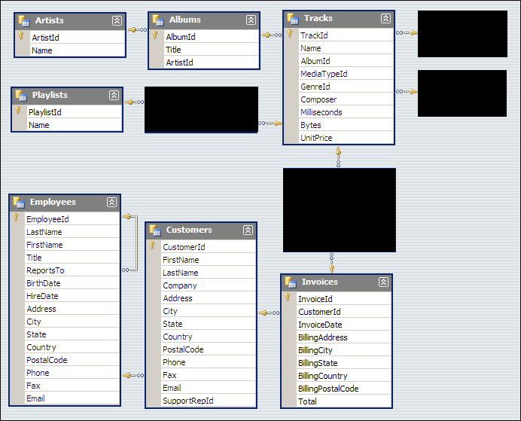



Artist to Albums



Customers to Invoices



Employees to Customers

3.

Question 3

When using SQLite, what datatypes can you assign to a column when creating a new table? Select all that apply.



Integer



Text



Null



Real

4.   
Question 4

Primary Keys must be unique values.



True



False

5.

Question 5

What is the query below missing in order to execute?

albums.title as album_title,

tracks.name as track_name

FROM tracks

JOIN albums ON tracks.albumid = albums.albumid

RunReset



The Column Names



A Comma



Select



From